Dynamic Classifier Selection using Local Class Accuracy on Overlap Cleaned Heterogeneous Pool of Experts

Martinus Alvin Haryanto
Computer Science Department, School of Computer Science, Bina Nusantara University,
Jakarta, Indonesia 11480
martinus.haryanto@binus.ac.id

Stefano Budi
Computer Science Department, School of Computer Science, Bina Nusantara University,
Jakarta, Indonesia 11480
stefano.budi@binus.ac.id

Joel Chriscendo Rahardjo, Liem
Computer Science Department, School of Computer Science, Bina Nusantara University,
Jakarta, Indonesia 11480
joel.liem@binus.ac.id

Kristien Margi S.Kom., M.Cs
Computer Science Department, School of Computer Science, Bina Nusantara University,
Jakarta, Indonesia 11480
Kristien.margi@binus.ac.id

Ricky Reynardo Siswanto, S.T., M.Kom.
Computer Science Department, School of Computer Science, Bina Nusantara University,
Jakarta, Indonesia 11480
Ricky.siswanto@binus.ac.id

Abstract
Student dropout prediction is still a challenging task in educational data mining especially for the datasets with severe class overlap and highly imbalanced distributions. We propose a transparent and augmentation free approach for data imbalance called Dynamic Classifier Selection - Local Class Accuracy (DCS-LCA). The framework is based on a heterogeneous ensemble of three different specialist models: Gaussian Naive Bayes, XGBoost and Support Vector Machine specialized for Dropout, Enrolled and Graduate classes, respectively. Before training, a K-Nearest Neighbors (K-NN) based overlap cleaning method is used to remove borderline noise, and then a One-versus-Rest strategy is performed to select features for each expert. Asymmetric cost-sensitive weighting is then driven by Optuna-based hyperparameter tuning, and forces each model to maximize the F1-score of its designated class. In the inference, DCS-LCA estimates local competence in the K-NN neighborhood and the final prediction is assigned to a single most competent expert. Empirical evaluation on UCI Student Dropout dataset (n=4,424) shows that the proposed framework achieves an outstanding accuracy of 91.62% and a macro F1-score of 0.8638, significantly alleviating class ambiguity and false-positive rates . The results show that DCS-LCA is a powerful substitute for data augmentation, providing accurate class-specific precision to identify at-risk students.

Keywords: Cost-sensitive Learning, Dynamic Ensemble Selection, Imbalanced Datasets, K-NN Overlap Cleaning, Local Class Accuracy, One-versus-Rest (OvR) Feature Selection, Specialist Pool, Student Dropout Prediction.

INTRODUCTION

Background
The problem of dropping out of university students is not only a personal academic problem, but also an important indicator of the effectiveness of the education system. This is not caused by one variable but is affected by complex multi-dimensional factors. Early identification of students at risk allows institutions to intervene proactively before problems develop. Machine learning can be employed to classify student risk status based on available institutional data that can optimize preventive measures for this phenomenon. Using machine learning models, the system can capture the interaction between an individual's academic performance and the surrounding socio-economic ecosystem.
The institutional dataset used in this study is UCI ML Repository 697 "Predict Students' Dropout and Academic Success" (Realinho et al., 2022). This dataset contains 4,424 student records with 36 features covering demographic, socioeconomic, and academic domains. The target class distribution is: Dropout (32.1%), Enrolled (17.9%), and Graduate (49.9%), indicating an imbalance in the dataset. Standard classification models can systematically introduce a bias where the model predominantly learns and recognizes patterns in the majority class (Graduate) but fails to recognize patterns in the at-risk classes (Dropout and Enrolled). Altalhan et al. (2025) state that this class imbalance causes the objective function of the standard classification algorithms to ignore minority examples, resulting in a distorted decision boundary and drastically reducing the model's sensitivity in detecting at-risk classes.
While previous attempts to leverage machine learning models to analyze this dataset have shown success in attaining strong macro accuracy levels, such models have to sacrifice their sensitivity in an attempt to cope with highly overlapping data (Lu et al., 2025; Villar & de Andrade, 2024). According to Villar and de Andrade (2024), gradient boosting algorithms and homogeneous ensemble models, such as LightGBM, CatBoost, and XGBoost, have a high possibility of surpassing the other methodologies when it comes to analyzing tabular education datasets. Nevertheless, such success depends mainly on the application of techniques such as SMOTE to enhance the F1score of the intermediary 'Enrolled' class up to 0.76, which, in turn, causes heavy distortion of the decision boundary when dealing with overlapping classes. According to Villar and de Andrade (2024), this technique makes it hard to predict the target classes, which have F1score equal to 0.86 ('Graduate') and 0.87 ('Dropout') using LightGBM and CatBoost. Nevertheless, there still exists one crucial problem common to all the previous methodologies most models designed to date remain constrained by their reliance on strictly global classifiers, leaving them incapable of dynamically adapting to the distinct heterogeneity of local subpopulations.

Problem Statement
Three shortcomings in the methodology that inspire the present research study relate to the following:

Class Overlap and Decision Boundary Distortion
The feature-space boundaries between Enrolled, Dropout, and Graduate students exhibit severe overlap, as confirmed by PCA and t-SNE analysis of this dataset. Conventional approaches based on literature to address class imbalanced problems generally use data resampling techniques, such as SMOTE and ADASYN. However, empirical testing evidence in the literature shows that these approaches fail to provide balanced performance across each target class; for example, the test report in Villar and de Andrade (2024) shows the F1score for all classes restricted to a suboptimal range of 0.64 to 0.78. The oversampling techniques SMOTE and ADASYN produce artificial overlapping samples near the decision boundary.

Incompatibility of Synthetic Oversampling Approach
Out of the total 36 attributes in the given dataset, 29 attributes (81%) are nominal or binary type. The use of SMOTE approach based on linear interpolation to deal with binary types attributes automatically generates values which do not lie within the discrete space {0,1}, thus completely undermining the logic behind such attributes (Fernandez-Garcia et al., 2021). This incompatibility demands another approach that may address the problem of imbalanced data and overlapping classes without tampering with the basic geometry of the feature space. Therefore, this study addresses these limitations by performing overlap cleaning prior to modeling and employing dynamic class weights optimized via Optuna to handle the class imbalance.

Static Ensemble Rigidity and Calibration Flaws
On the other hand, the application of conventional static ensembles through a probability harvesting or soft voting from multiple independent base classifiers assumes that the probability estimates from independent classifiers have been properly calibrated across the feature space (Osei et al., 2025). This static approach has been proven to force a rigid combination of model weights in generalizing across the characteristics of heterogeneous data spaces (Cordeiro et al., 2023; Liu et al., 2023). As a result, the global ensemble model fails to consider the instance hardness of individual samples and ignores variations in the local competence of each base model on a particular feature subset (Liu et al., 2023). This limitation causes the static global model to drastically lose sensitivity when distinguishing critical samples located in borderline instances. In such situations of low class separability, empirical evidence from Liu et al. (2023) shows that DES provides an important edge over static classifiers. In addition, Fachrie et al. (2025) verified that overlapping classes are the most influential single cause of poor multiclass imbalanced classification performance, even more than the imbalance ratio itself.

Research Objectives
- Apply K-Nearest Neighbors (K=10) overlap cleaning on the whole population with purity level set to be 0.4 to filter out borderline noises and ensure that there is a distinct boundary of each class in the whole population.
- Implement an One-vs-Rest (OvR) feature selection approach in order to choose relevant class discrimination features so that models can focus on some special classes.
- Construct a heterogeneous pool of expert models consisting of individual standalone specialists trained using asymmetric cost-sensitive hyperparameter tuning with Optuna to maximize class-specific F1score.
- Develop a dynamic selection mechanism via Dynamic Classifier Selection based on Local Class Accuracy (DCS-LCA), creating a spatial localization scheme with K=7 to assess and allocate prediction tasks to the best local expert model.
- Evaluate and compare the predictive performance of the proposed DCS-LCA dynamic ensemble strategy and a static ensemble strategy using the Probability Harvesting soft voting technique.

Research Contribution
- A population level KNN overlap cleaning protocol that eliminates distributional shift between training and evaluation sets, enabling honest CV score reporting.
- An augmentation-free, distribution-preserving framework that addresses severe class imbalance and overlap without employing synthetic oversampling techniques such as SMOTE.
- Static Baseline using the Probability Harvesting technique where the dynamic aspect is separated from the pool construction process.
- Novel Hybrid Dynamic Framework using three specialist DCS-LCA pipeline with asymmetric Optuna tuning, to our knowledge not previously reported in the educational prediction literature.

LITERATURE REVIEW

Student Dropout Prediction in Educational Data Mining
Two critical issues related to the research involving the use of student data are that of feature heterogeneity and class imbalance. The former issue was shown by Singh and Alhulail (2022) through a logistic regression model with four stages, where the intuition behind selecting features, such as parents' educational background and their economic status, was shown to be incorrect. This shows that a more rigorous approach towards the selection of features must always be preferred over making subjective assumptions based on the domain knowledge.
On the UCI ML Repository #697 data set, Villar and De Andrade (2024) found that LightGBM and CatBoost trained using Optuna optimization always perform better than conventional classification algorithms. Lu et al. (2025) enhanced the accuracy of the dropout prediction by performing clustering at the level of individual courses and managed to improve the AUC metric by 7.5% and F1-Score metric by 18.2%. Goran et al. (2024) used a metaheuristic optimization XGBoost model with a SHAP TreeExplainer and found that the number of curricular units approved per semester and tuition payment status were the most significant variables, which also emerged in most studies performed by research specialists in this domain. Kabumba et al. (2025) achieved AUC = 0.95 using a SMOTE-balanced Random Forest on the same data set. However, this result was obtained at the cost of synthetic interpolation across predominantly nominal and binary features, which produces geometrically invalid fractional values outside the discrete domain {0,1}, introducing artificial decision boundary distortions that misrepresent the true feature geometry of the dataset.
Existing works on this dataset suffer from a common structural limitation: they rely on a single global classifier that imposes the same decision boundary across the whole feature space. Such an approach cannot capture, by construction, the local heterogeneity of students’ behaviors leading to dropout. Fernandez-Garcia et al. (2021) demonstrated that stage-specific decomposition of the prediction task raised recall from 72% at enrollment to 91.5% by the fourth academic stage, confirming that locally scoped classifiers substantially outperform global models on structurally distinct student subpopulations. Similarly, Fachrie et al. (2025) established that class overlap adversely impacts multi-class imbalanced classification more severely than imbalance ratio does. Specifically, severe class overlap necessitates a sacrifice of sensitivity by the optimal global classifier when minimizing overall loss, thereby underperforming on the difficult-to-classify group Enrolled.
This unresolved tension between the requirement for predictive expressivity across a heterogeneous student body and the structural limitations imposed by globally uniform classifiers forms the primary methodological gap addressed by this paper. To date, none of the research performed on this data set has been able to simultaneously build specialist classifiers for each class and utilize asymmetric cost-sensitive optimization, class-dependent OvR selection of features and dynamic decision-making based on local accuracy per class.

Class Imbalance Handling and Overlap Cleaning
In an imbalanced multiclass classification scenario, Fachrie et al. (2025) proved that class overlap affects classification negatively more dominantly compared to imbalance ratio, such that some resampling methods not only fail but actually harm the performance of the baseline models. According to the systematic study of Altalhan et al. (2025), accuracy should not be used as a measure in case of severe imbalance, and that a combined approach of data purification with algorithm-level penalties yields the most robust performance across configurations.
Velarde et al. (2024) have evaluated tree boosting algorithms using balanced and unbalanced risk assessment data sets and have observed that SMOTE does not necessarily enhance the performance of classification tasks and in some cases may even deteriorate the results compared to tree classifiers. These issues become especially relevant when applying SMOTE to the UCI 697 data set, in which 29 (81%) out of 36 attributes are categorical or binary in nature where the linear interpolation of SMOTE in binary space produces fractional values outside the discrete domain {0,1} which undermines the logistic validity of these features
In their experiments conducted via simulation, Arshad et al. (2025) proved that tree-based classifiers and neural network models become more sensitive as the ratio of the minority class becomes less than 25-30%. According to Wang et al. (2025), the KSDE weighted ensemble method with different sampling rates beats the SPE method due to better noise handling and achieves generalization using an ensemble weighing strategy. Building upon this approach, this paper enhances the technique by independently tuning the class weight hyperparameter for each classifier specialist through Optuna optimization, removing the restrictive fixed weight approach of traditional cost-sensitive ensembles.
Overlapping clean up based on KNN - employing purity as proportion of K=10 equally labeled nearest neighbor instances with threshold value of 0.4 works on the premise of hardness instance analysis via local neighborhoods that has been well substantiated by recent literature. According to Fachrie et al. (2025), class overlap turns out to be the key limiting factor in imbalanced multiclass classifier performance, overtaking the imbalance ratio itself for impact, thereby making direct intervention on class overlaps becomes crucial as the key preprocess step. Consistent with this, results from Wu et al. (2021) for imbalanced medical data sets also show that use of Edited Nearest Neighbors (ENN) for removal of noisy and borderline instances with respect to the local neighborhood turned out to be a vital process for improvement in model's accuracy to 99.81% and F1 Score of 99.86% on highly imbalanced medical data. These achievements substantially outperform the baseline without editing, with the superiority directly attributed to the ENN's ability to effectively reduce class overlap around the decision boundary.

Specialist Feature Selection and Asymmetric Cost-Sensitive Models
The predominant methodology in current research applies feature selection as a global procedure involving optimization of one feature representation for all classes at once. According to Malik et al. (2025), a method of selecting features in an iterative manner, whereby different feature sets are selected per iteration, consistently yields better results than one-step global selection; this implies that diverse feature representations have more predictive power than the combined but weak representation that arises from global selection. Osei et al. (2025) further reinforced this point through mathematical proofs that diversity in model representation, including feature set diversity, is an essential factor of ensemble success. The same was demonstrated by Jain et al. (2025) in relation to the problem of predicting school dropouts, where an ensemble of RF and XGBoost models using PSO for weight tuning, where each component of the model is considered individually, reached F1score = 0.8633, thereby surpassing the performance of the ACO and Firefly algorithms based on the global uniform representation. The present paper departs from this practice by considering the feature selection process separately for each model and each class.
In this case, the decomposition algorithm uses a Binary One-vs.-Rest (OvR) formulation strictly during the feature selection phase, in which the multiclass problem is temporarily simplified into a binary classification problem ${y_{i}}^{(c)}= 1[y_{i} = c]$ for each particular class c to isolate class-specific feature importance. Such a procedure results in feature relevance scores which are fully specific to one target class, independent of the inter-class competitive pressures that in global selection tend to obscure the discriminative signal of volatile minority classes. Crucially, this binary reduction is restricted entirely to feature subset evaluation; the subsequent training and optimization of each model are still executed natively on the original three-class dataset. In alignment with this rationale, Aziz et al. (2025) demonstrated the validity of this concept through heterogeneous DES-based research, wherein diverse feature representations for each classifier in the ensemble produced the highest values for precision, recall, F1 score, and G-mean amongst all other tested settings in the problem of predicting crash severity levels with an imbalanced multiclass dataset. The application of a hybrid stacking model for analyzing the features independently of each ensemble member resulted in a higher multiclass classification accuracy than the traditional ensembles with consistent feature representation (Ganie et al., 2025).
The decision of feature selection approach for each algorithm was made considering the alignment of the assumptions of the model with properties of the relevance measure used. In case of XGBoost, feature importance derived from the binary OvR model was selected because the algorithm's accumulated split gain directly quantifies the contribution of each feature to the gradient-based reduction of the loss function. This mechanism yields a feature ranking that is highly sensitive to non-linearities and complex feature interactions, which are typical characteristics of tabular data (Goran et al., 2024; Villar & de Andrade, 2024). Goran et al. (2024) empirically validated this approach on the same UCI 697 dataset, where XGBoost feature importances identified approved curricular units per semester and tuition status as dominant predictors with high consistency. Concurrently, the SVM model uses the Recursive Feature Elimination (RFE) method, which works with the base estimator as LinearSVC, because the SVM margin will be affected by features that blur the binary hyperplane, and RFE addresses this by systematically eliminating features based on their weight coefficients through a recursive process (Jain et al., 2025). Furthermore, RFE is performed after removing binary and noisy columns, since low-variance binary features have been shown to negatively impact the estimation of SVM margins (Aziz et al., 2025). Finally, Mutual Information (MI) was chosen for Naive Bayes (NB) because it captures the non-linear dependency between each feature and the OvR binary target variable without making any distributional assumptions, which is consistent with NB's conditional independence assumption: the features with high MI to the binary variable have gained maximum information from the NB probability model (Ganie et al., 2025).
Following the determination of the feature subset per specialist, hyperparameter tuning was performed using Optuna based on an objective function which maximized for F1 score associated with the respective class, rather than its macro average score through a stratified 5-fold cross validation approach. The effectiveness of Optuna in optimizing hyperparameters over other methods like grid search and random search had already been demonstrated by Villar and De Andrade (2024) on the UCI 697 dataset. The class weight parameters were also optimized as Optuna parameters, rather than manually set, so that the weight multipliers for the specialist class and the other classes were found jointly with the model's hyperparameter configuration, eliminating the fixed weight assumption that in practice limits performance (Wang et al., 2025). Arshad et al. (2025) confirmed that when the minority class ratio is below 25-30%, tree-based models with optimized class weighting consistently yield higher sensitivity, a scenario that precisely applies to the imbalanced nature of the Enrolled class in this study.

Dynamic Ensemble Selection and Local Competence Measurement
Ensemble learning performs better compared to a single model because of the error independence and function diversity among a set of base classifiers (Mienye & Sun, 2022). Osei et al. (2025) explain that the independence of the errors among the estimates made by different models outweighs the accuracies of individual models. They demonstrated that a highly diverse pool of models with a 48% higher individual error rate still yielded superior ensemble performance compared to a less diverse pool, provided it exhibited a 50% greater disagreement diversity. Static techniques such as soft voting, averaging, and stacking become ineffectual in cases of imbalance and overlaps in datasets due to the inherent biasness developed by the base learners towards the majority class in globally trained learners, resulting in overconfident posteriors which statistically overshadow the locally minority data (Fachrie et al., 2025; Wang et al., 2025). Based on the empirical results of Fachrie et al. (2025), it can be concluded that class overlap and not imbalance ratio leads to performance deterioration in multiclass classifiers, therefore, making the static combination method invalid in case of high overlap conditions. This failure is precisely what motivates the utilization of dynamic selection over static combination as the final aggregation mechanism, while the proposed Probability Harvesting method in this study becomes the controlled static baseline since the goal is to determine the extent of the performance increase achieved through pool formation separately from dynamic selection within a neighborhood environment.
The DES and DCS architectures are able to overcome this global rigidity not by employing static combination strategies, but by assessing the performance of each base learner in terms of a Region of Competence (RoC) that is defined spatially around each test case individually. There is robust empirical support for the effectiveness of this approach. Liu et al. (2023) demonstrated the advantage of dynamic instance selection over global combination in terms of structural efficiency, by showing on the basis of 54 benchmark classification problems that DES algorithms in cases with unbalanced class sizes always outperform static ensembles with or without resampling. Wu et al. (2021) found that using DES along with SMOTE-ENN on unbalanced medical data produced an accuracy of 99.81%, an F1 score of 99.86%, and an AUC value of 99.81%, decisively beating a DES bagging algorithm without any neighborhood selection because of the class overlap reduction through ENN editing. Aziz et al. (2025) applied DES guided by instance hardness and region of competence to imbalanced multiclass road crash severity prediction and achieved the highest precision, recall, F1-score, and G-mean among six competing DES configurations. The result proves that with local structure information being added to the competence estimation step, dynamic ensemble selection performs better than either static combination or less intelligent DES. Another research done by Cordeiro et al. (2023) proved that adding the instance hardness information into the competence estimation step was better than four different DES methods tested under heterogeneous pool setups.
Among class-based local competence methods, Local Class Accuracy (LCA) proves especially valuable when high overlap exists alongside imbalance. As opposed to KNORA-E, where the base classifier must make accurate predictions over all K neighbors belonging to the local neighborhood for it to be classified by the oracle as having passed the threshold, LCA considers each classifier according to its accuracy only over the subset of neighbors that share the same class label as the classifier prediction. Choi and Lim (2021) argue that in the case of very high-overlap regions, the oracle constraint for KNORA-E results in void classifier ensemble selection where there are no classifiers that have managed to clear the oracle threshold. In such scenarios, either random or majority voting is performed without utilizing any discriminative power from the local neighbors. The void selection scenario is guaranteed to happen specifically in the region where enrolled and graduate classes are heavily overlapping in the UCI 697 dataset according to PCA and t-SNE results. LCA addresses this issue through its architectural construction, wherein a specialist that performs well on local accuracy for its designated class neighbors is assigned high priority irrespective of how it performs on other class neighbors, thus making it possible for the asymmetric training property of a specialist to pass on to the final result. As demonstrated by Choi and Lim (2021), DES architectures demonstrate the maximum margins compared to static ensembles only when the class separation is difficult and there is a significant variance in the features between them, which is precisely the case with this data set, thereby justifying the use of DES for this particular data set.

METHODOLOGY
Let the full dataset be $D ={\{(x_{i}, y_{i})\}}_{i=1}^{N}$ where x_{i} ∈ R^{d} (d = 36) and y_{i} ∈ Y = {0,1,2} corresponding to Dropout, Enrolled, and Graduate respectively. The class distribution is Dropout (32.1%), Enrolled (17.9%), Graduate (49.9%) with imbalance ratio ≈ 1.8 : 1.0 : 2.8.

Phase 1 : Data Preprocessing
Feature Engineering
Domain-specific features are constructed prior to any splitting or cleaning. Key derived features include : Pass Rate per semester $({PR}_{s}= \frac{{Approved}_{s}}{{Enrolled}_{s}} )$, Academic Momentum $({PR}_{1} . {PR}_{2})$, Academic Fatigue $({PR}_{1} - {PR}_{2})$, Grade Trend, Financial Stress score (sum of Debtor, late tuition, and no scholarship indicators), and Dropout Risk composite. These features encode latent temporal and financial signals not directly present in raw enrollment counts.
Encoding and Scaling
Categorical features are encoded using TargetEncoder with smoothing λ = 10 to mitigate target leakage on high-cardinality columns. All features are then standardized using StandardScaler (zero mean, unit variance) to ensure that Euclidean distances computed during KNN overlap cleaning are not dominated by features with large numerical ranges.

Population-Level KNN Overlap Cleaning
Overlap cleaning is applied to the full population before any train-test split. For each sample $x_{i}$, the local purity score is defined as:
$$Purity (x_{i}) = \frac{1}{K} \sum_{j ∈ N_{K}(x_{i})}{1[y_{j}=y_{i}] }$$
where $N_{K}(x_{i})$ denotes the K = 10 nearest neighbors of $x_{i}$. Samples with $Purity (x_{i})$ < 0.4 are classified as borderline noise and dropped. Applying cleaning before splitting ensures that both training and test sets are drawn from the same cleaned distribution, eliminating the distributional shift that whould otherwise produce artificially optimistic cross-validation score. A purity threshold of 0.4 was chosen because this value detects and removes borderline noise with precision, namely data points that have less than 40% of their neighbors with the same label within the K=10 range. This setting is based on instance hardness analysis to effectively clean the transition zones between classes without discarding samples from the core area.
Train-Test Split
Then dataset is split into 80% training and 20% test data using stratified sampling after cleaning.
Then, TargetEncoder and StandardScaler are fitted again only on the training partition to avoid data leakage from the test set.

Phase 2 : Specialist Pool Construction
One versus Rest Feature Selection
Each specialist gets a class-specific feature subset extracted from a temporary binary reformulation:
$${y_{i}}^{(c)} = 1[y_{i} = c], c ∈ \{0,1,2\}$$
Naïve Bayes (Dropout specialist, c = 0): top 18 features ranked by Mutual Information on $y^{(0)}$. XGBoost (Enrolled specialist, c = 1): the top 20 features ranked by XGBoost binary importance on $y^{(1)}$. SVM (Graduate specialist, c = 2): top 15 features from RFE with LinearSVC on $y^{(2)}$; binary and noisy columns are excluded prior to RFE to reduce margin blurring. The binary OvR algorithm separates subsets of features that have the strongest relevance specifically for each target class. This separation dampens the "signal competition" between classes, where the diversity of feature representations has been shown to significantly enhance the prediction sharpness of the ensemble architecture.
Asymmetric Cost-Sensitive Optuna Learning
Then, each model is tuned with Optuna hyperparameter search (150 trials for XGBoost, 80 trials for SVM and 80 trials for NB) using 5-fold Stratified K-Fold cross-validation. where the Optuna objective function for model m on class c is:
$$L_{m} = \frac{1}{|folds|} \sum_{f}{{F1}_{c}({y ̂}_{f}, y_{f})}$$
where F1c is the class-specific F1-score for class c only—not the macro average. Sample weights within each fold are also tuned as Optuna parameters:
$$w_{i}=\left\{\begin{aligned}w_{c}^{*}, &, if y_{i}= c \\ w_{other}^{*}, &, otherwise\end{aligned}\right.$$
where $w_{c}^{*}$ and $w_{other}^{*}$ are tunable Optuna parameters. This asymmetric weighting allows each specialist’s penalty structure to be jointly optimized with its hyperparameters rather than fixed a priori.

XGBoost Optuna Objective Search
The bounds for XGBoost Optuna objective search were all chosen with valid reasons. The bounds for n_estimators [200,800] were chosen to avoid underfitting and overfitting, since less than 100 trees won’t be able to understand complex feature patterns in tabular dataset, while performance returns diminishingly beyond 500-1000 estimators (Chen & Guestrin, 2016). The bounds for max_depth [3:8] was chosen because cleaning KNN overlaps meant that borderline noises were also removed and to avoid over-memorizing of ambiguous datapoints near class boundaries. The boundaries for learning_rate were chosen based on Chen & Guestrin (2016) better performance compared to the aggressive learning_rate, also aligned with the boundaries used by Villar & de Andrade (2024). Boundaries for subsample and colsample_bytree were determined under 0.6 because the Enrolled class contributes only 367 post-cleaning training samples, and fewer than 0.6 risks producing subsets with near-zero Enrolled representation in some trees. Boundaries for reg_alpha and reg_lambda were chosen following the best-practice guide for Optuna (Akiba et al., 2019) for L1/L2 regularization, covering the full range from almost-zero to moderate penalty. For class weights, enrolled_weights was floored at 4.0 to compensate the 5.8:1 ratio of Graduate-to-Enrolled imbalance ratio, while dropout_weight and graduate_weight were searched in a small range [0.5, 1.5] to create small penalty without undermining overall multiclass calibration.

SVM Optuna Objective Search
The bounds for SVM’s C variable were set at [0.1, 1000], consistent with the guide by Hsu et al. (2003) who recommended searching C between [0.03, 32768]. Bounds of gamma [1e-4, 10] also followed Hsu et al. (2003) who recommend [3e-5, 8]. Log scale is used for both gamma and C because SVM behaviour varies exponentially with those parameters. The sigmoid kernel was excluded because sigmoid kernels on standardized data frequently produce indefinite kernel matrices landscapes, as stated by Schölkopf & Smola (2001). The bounds of graduate_weight was determined at [1.0, 5.0], since Graduate class remains the dominant class even after cleaning the dataset.

Naïve Bayes Optuna Objective Search
Naïve Bayes’ var_smoothing ranges at [1e-10, 1e-1] spans under to above the default magnitude of sklearn’s 1e-9, allowing exploration of both near-default and heavy smoothing. A wide range of var_smoothing ensures Optuna can find the sweet spot to avoid numerical instability in the Gaussian likelihood due to StandardScaler. The dropout_prior range [0.35, 0.8] was chosen to enforce proper inflation as principled cost-sensitive mechanism, purposefully set above the empirical post-cleaning rate of 30.2%. The dropout_weight range [2.0, 10.0] acts as a second axis of Dropout sensitivity, together with the dropout_prior.

Final Specialist Configurations
The optimal configurations identified by Optuna are:
- XGBoost (Enrolled): n_est = 758, max_depth = 4, strict L1/L2 regularization, enrolled weight = 19.22.
- SVM (Graduate): RBF kernel, C = 29.76, γ = 0.0063, graduate weight = 1.07.
- NB (Dropout): var_smoothing = 5.66 × ${10}^{-5}$, ${prior}_{Dropout}$ = 0.797, dropout weight = 5.007.

Feature Metadata Retention
The column index arrays for each specialist (xgb_feat_idx, svm_feat_idx, nb_feat_idx) are saved as specialist_feature_indicates.pkl. The feature-SubsetWrapper class guarantees that all three specialists receive the full matrix at inference time, internally slicing columns to maintain dimensional consistency with their training geometry.
Probability Harvesting (Static Baseline)
Each specialist produces a $N_{test}$ × 3 probability matrix. The harvesting operation extracts only the column corresponding to each specialist’s designated class:
$$H = [P_{NB}(y=0 | x) P_{XGB}(y=1 | x) P_{SVM}(y=2| x)]$$
Row-wise stochastic normalization yields ${H˜}_{ ij} = H_{ij} /\sum_{k}{H_{ik}}$ and the final prediction is $\hat{y}=argmax_{\left(c\right)}\tilde{H_{c}}\left(x\right)$. This static method serves as the primary baseline, isolating the contribution of specialist-pool construction from dynamic selection.
Dynamic Classifier Selection-Local Class Accuracy
- Dynamic Ensemble Selection Construction
The training set is further split into a base-train set (70%) used to re-train the pool and a Dynamic Selection dataset DSEL (30%) used exclusively for competence estimation. Pool classifiers are re-trained on base-train using the same specialist configurations from Phase 2. The DSEL set is never used during pool training.
- DCS-LCA Algorithm
For each test instance $x_{test}$:
Step 1 – Spatial Localization. Identify K = 7 nearest neighbors $N_{K}(x^{test}) ⊂ D_{DSEL}$ using Euclidean distance on the full feature matrix.
Step 2 – Local Class Accuracy Scoring. For each specialist $C_{m}∈ \{C_{XGB}, C_{SVM}, C_{NB}\}$ :
- Obtain initial prediction: ${\hat{c}}_{m}= C_{m}(x^{test})$
- Apply local mask : $M_{m} = \{j∈N_{K} : y_{j }={\hat{c}}_{m}\}$
- Compute Local Class Accuracy :
$$LCA(C_{m}) = \left\{\begin{aligned}\frac{1}{|M_{m}|}\sum_{j∈M_{m}}{1\left[C_{m}\left(x_{j}\right)=y_{j}\right], |M_{m}|>0} \\ 0 , |M_{m}| = 0\end{aligned}\right.$$
Step 3 – Single Delegation. Delegate prediction to the specialist with maximum LCA :
$$\hat{y}= C_{m^{*} }(x^{test}), m^{*} = arg⁡\max_{m} LCA(C_{m})$$
The zero-competence assignment (LCA = 0 when $|M_{m}|$ = 0) penaltizes specialists whose prediction for $x^{test}$finds no supporting evidence in the local neighborhood, naturally discouraging specialists from claiming regions outside their competence.

RESULTS AND DISCUSSION

Results
Data Preprocessing and KNN Overlap Cleaning
- Dataset Overview and Class Distribution
The raw dataset consists of 4424 student records with 36 features. Before data cleaning, the class distribution is imbalanced with Dropout (32.1%), Enrolled (17.9%) and Graduate (49.9%). Nine categorical columns were transformed using a Target Encoder with a smoothing factor of 10 to deal with high cardinality. Further, 17 engineered features such as Pass_Rate_Sem1/Sem2, Academic_Momentum, Financial_Headache, Dropout_Propensity and Stability_of_Enrollment were created, and the feature space was increased to 53 dimensions. To reduce noise and combat class imbalances across the student population, data pre-processing was done using K-Nearest Neighbors (KNN) with K=10 and a competence threshold of 0.4. Table I details the final class distributions alongside the exact deletion counts and percentages from the data cleansing pipeline.

Table 1. Class distribution before and after KNN overlap cleaning
Class | Initial Rows | Proportion (%) | Cleaned Rows | Rows Removed | % Removed
Dropout | 1,421 | 32.12% | 1,080 | 341 | 24.00%
Enrolled | 794 | 17.95% | 367 | 427 | 53.78%
Graduate | 2,209 | 49.93% | 2,132 | 77 | 3.49%
Total | 4,424 | 100% | 3,579 | 845 | 19.10%

- KNN-Based Overlap Cleaning Results
From Table 1, shows that 845 entries (19.10%) were discarded from the data. The Enrolled class faced the highest boundary overlap, resulting in a 53.78% deletion rate due to its highly ambiguous transitional nature. For the Graduate class, there were only 3.5% discards, indicating a lower degree of overlap with boundaries. On the other hand, 24.0% records of the Dropout class were discarded. This population-level KNN cleansing is implemented before the train-test split to maintain a consistent data distribution across all samples (Wang et al., 2025). Unlike synthetic oversampling (e.g., SMOTE or ADASYN), this techniques generates no artificial sample—guarantees the purity of binary and nominal features, which constitute 81% (29/36) of the initial feature dimensions (Velarde et al., 2024).
- PCA Visualization: Before vs. After Cleaning
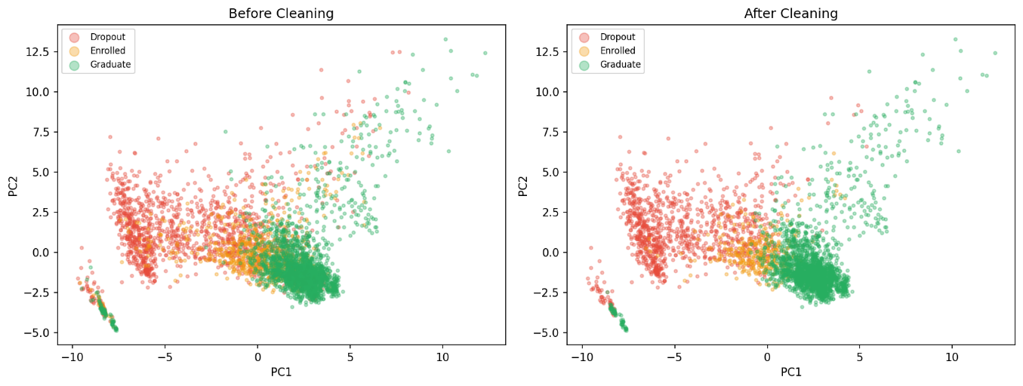
Figure 1. PCA (2D) projection of the dataset before and after cleaning using KNN
Source : Experimental Results (2026)

Figure 1, displays a two component PCA projection of the full dataset before and after KNN cleaning. The visualisation confirms that the cleaning procedure selectively removes points in high-overlap transitional zones, in particular at the boundary between the Enrolled (orange) and Dropout (red) clusters. We keep the essential structure of each class, but we remove the borderline noisy instances at the class boundaries. The Graduate cluster (green) in the lower right quadrant is mostly intact in agreement with its low removal rate.

OvR Feature Selection and Specialist Model Configuration
We used a one-vs-rest (OvR) binary decomposition, which was only implemented during the feature selection phase, to create three specialized classifiers targeting a specific student outcome category. This yields class-specific feature relevance scores that are independent of inter-class competition suppressed by global selection approaches (Malik et al., 2025).
- One-vs-Rest Feature Selection per Specialist
Table 2. Specialist model configuration
Algorithm | Target Class | Selection Method | Total Selected Features
Naive Bayes | Dropout (Class 0) | OvR XGB Feature Importance | 18
XGBoost | Enrolled (Class 1) | OvR Recursive Feature Elimination | 20
RBF-SVM | Graduate (Class 2) | OvR Mutual Information | 15

The optimized subsets of features were obtained from the sensitivity analysis, where the goal was to minimize complexity and enhance accuracy according to the tolerance levels of the algorithms. Specifically, RBF-SVM achieved peak generalization with only 15 features to avoid local hyperplane overfitting, whereas XGBoost and Naive Bayes required 20 and 18 dimensions, respectively, to accommodate complex tree splits and fulfill local feature independence conditions.
- Optuna Hyperparameter Tuning Strategy
Table 3. Optuna Search Space and Best CV Result per Specialist
Specialist | Trials | Objective | Search Space (Key Parameters) | Best CV Score
Naive Bayes  (Dropout) | 80 | F1 Dropout (5-fold CV) | var_smoothing [1e-10,1e-1], dropout_prior [0.35,0.8], dropout_weight [2.0,10.0] | F1 Dropout = 0.8720
XGBoost  (Enrolled) | 150 | F1 Enrolled (5-fold CV) | n_estimators [200,800], max_depth [3,8], learning_rate [0.005,0.05], subsample [0.6,1.0], colsample_bytree [0.6,1.0], gamma [0,5], reg_alpha [1e-8,10], reg_lambda [1e-8,10],  min_child_weight [1,10],  enrolled_weight [4.0,20.0], dropout_weight [0.5,1.5], graduate_weight [0.5,1.5] | F1 Enrolled = 0.7250
SVM  (Graduate) | 60 | F1 Graduate (5-fold CV) | kernel {rbf, poly}, C [0.1,1000], gamma [1e-4,10], graduate_weight [1.0,5.0] | F1 Graduate = 0.9607
Table 4. Best Hyperparameter Configuration per Specialist
Hyperparameter | Naive Bayes (Dropout) | XGBoost (Enrolled) | SVM (Graduate)
n_estimators / C / var_smoothing | 5.659e-05 | 758 | C = 29.756
max_depth / gamma / dropout_prior | prior = 0.7971 | 4 | gamma = 0.0063
learning_rate / kernel | - | 0.04285 | RBF
subsample / colsample_bytree | - | 0.872 / 0.861 | -
Class weight (target) | dropout_weight = 5.007 | enrolled_weight = 8.135 | graduate_weight = 1.664
Class weight (others) | - | dropout_w = 0.856, grad_w = 0.944 | -

Table 4 reveals that there are some important hyperparameters for the XGBoost model, the optimal value for enrolled_weight is 8.135 within a range of 4.0 to 20.0, where the penalty imposed on misclassification is eight times higher than default due to lower density (10.3%). Moreover, max_depth = 4 ensures that the trees will not remember borderline noise after cleaning. On the other hand, the RBF-SVM Graduate expert pairs C=29.756 with a broad kernel ($γ$ = 0.0063) to establish a smooth, large-margin boundary. This configuration clearly isolates the densely clustered graduate examples with nearly perfect testing recall (0.99), which consequently allows for a low class weight of 1.664. Finally, the Naive Bayes dropout expert uses a heavy dropout_prior of 0.7971 to override the empirical prior (28.6%). Together with a dropout_weight of 5.007, this helps shape the prior and modify the loss surface. This two-view approach allows for the optimization of the Dropout F1-score (CV = 0.8720) under the assumption of Gaussian independence, as suggested by Arshad et al. (2025).

Individual Specialist Model Evaluation
- Naive Bayes (Dropout Specialist)
The Gaussian Naive Bayes expert was optimized for F1-score of Dropout class with Mutual Information selected features. The conditional independence assumption of Naive Bayes makes it a good choice for high-dimensional, categorical-heavy feature spaces; after target encoding this assumption is still a reasonable approximation.

Table 5. Naive Bayes (Dropout Specialist) Classification reports and AUC metrics
Metric | Dropout (0) | Enrolled (1) | Graduate (2) | Macro Avg
Precision | 0.89 | 0.49 | 0.96 | 0.78
Recall | 0.83 | 0.71 | 0.92 | 0.82
F1-Score | 0.86 | 0.58 | 0.94 | 0.79
Support | 216 | 73 | 427 | 716
ROC-AUC (OvR) | 0.963 | 0.904 | 0.967 | 0.9447

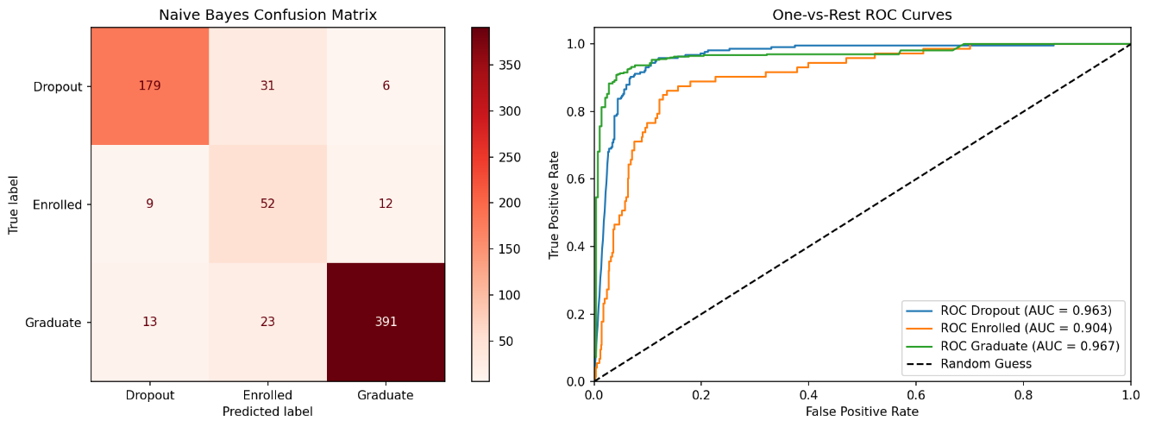
Figure 2. Naive Bayes Confusion Matrix and OvR ROC Curves
Source : Experimental Results (2026)

Three different specialist classifiers (Naive Bayes, XGBoost, and SVM) were separately analyzed to evaluate the localized classification performance. The Naive Bayes Dropout specialist sets a strong benchmark with an F1-score of 0.86 and a Recall of 0.83, and its dropout AUC (0.963) is still very competitive, narrowly behind XGBoost (0.989). This small marginal improvement is more than compensated by the distinctive complementary capabilities existing among the set of classifiers, where XGBoost specializes in discriminating the Enrolled category, SVM dominates with high specificity to Graduate, and Naive Bayes achieves optimal sensitivity towards Dropout.

- XGBoost (Enrolled Specialist)
The XGBoost specialist was optimised with the primary objective of maximising F1-score for the Enrolled class.

Table 6. XGBoost (Enrolled Specialist) Classification reports and AUC metrics
Metric | Dropout (0) | Enrolled (1) | Graduate (2) | Macro Avg
Precision | 0.95 | 0.65 | 0.96 | 0.85
Recall | 0.89 | 0.78 | 0.95 | 0.88
F1-Score | 0.92 | 0.71 | 0.95 | 0.86
Support | 216 | 73 | 427 | 716
ROC-AUC (OvR) | 0.989 | 0.960 | 0.988 | 0.9790

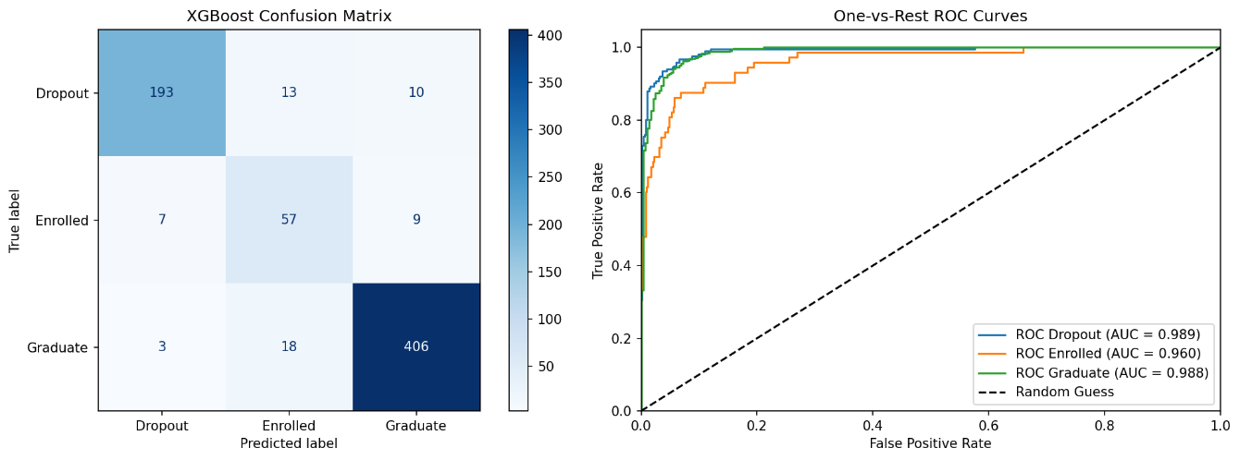
Figure 3. XGBoost Confusion Matrix and OvR Roc Curves
Source : Experimental Results (2026)

The XGBoost expert provides outstanding results while predicting the student trajectory by achieving an F1-score of 0.71 in the Enrolled category. The confusion matrix shows that both errors in the Dropout and Graduate categories are symmetric in nature and hence represent the changing and dynamic characteristics of the Enrolled category. As all local specialists perform their roles independently and do not overlap with any other model, no single one is capable of dominating the whole decision space. Finally, the consistent AUC values indicate that all conditions required to deploy the DCS-LCA approach have been fulfilled.

- SVM (Graduate Specialist)
The SVM specialist uses a radial basis function (RBF) kernel optimised for the Graduate class F1-score. The SVM's maximum-margin decision boundary provides strong separation for the well-defined Graduate cluster, which the PCA visualisation confirmed to be the least overlapping class.
Table 7. SVM (Graduate Specialist) Classification reports and AUC metrics
Metric | Dropout (0) | Enrolled (1) | Graduate (2) | Macro Avg
Precision | 0.91 | 0.73 | 0.92 | 0.85
Recall | 0.89 | 0.48 | 0.99 | 0.78
F1-Score | 0.90 | 0.58 | 0.95 | 0.81
Support | 216 | 73 | 427 | 716
ROC-AUC (OvR) | 0.979 | 0.935 | 0.987 | 0.9672

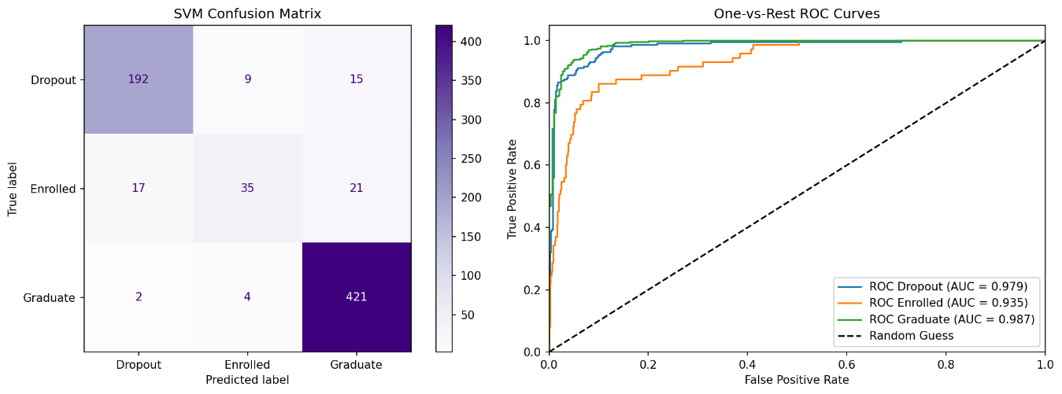
Figure 4. SVM Confusion Matrix and OvR Roc Curves
Source : Experimental Results (2026)

Completing the heterogeneous pool, the SVM specialist performs excellently in localized conditions for the completion trajectory, with a Graduate F1-score of 0.95 and a recall of 0.99. This proves its suitability as the designated Graduate predictor in the ensemble model. On the other hand, the localized Enrolled F1score (0.58) falls sharply, making it the worst-performing of the three specialists. The drop in performance at the local level does not have any impact on the effectiveness of the process since the DCS-LCA method makes sure that the SVM expert is only selected in its optimal zones.

Baseline Evaluation using Probability Harvesting
The probability harvesting baseline applies a static soft-voting mechanism that constructs a new probability vector by extracting class-specific predictions from their corresponding optimal specialists: Dropout from Naive Bayes, Enrolled from XGBoost, and Graduate from SVM. This vector is then renormalized to sum to 1, with the final prediction determined via the argmax operator. This fixed model configuration effectively isolates the performance impact of the dynamic selection process from other architectural variables.

Table 8. Probability Harvesting (Baseline) Classification Report
Metric | Dropout (0) | Enrolled (1) | Graduate (2) | Macro Avg
Precision | 0.89 | 0.63 | 0.94 | 0.82
Recall | 0.85 | 0.71 | 0.94 | 0.83
F1-Score | 0.87 | 0.67 | 0.94 | 0.83
Support | 216 | 73 | 427 | 716
ROC-AUC (OvR) | 0.978 | 0.949 | 0.983 | 0.9697

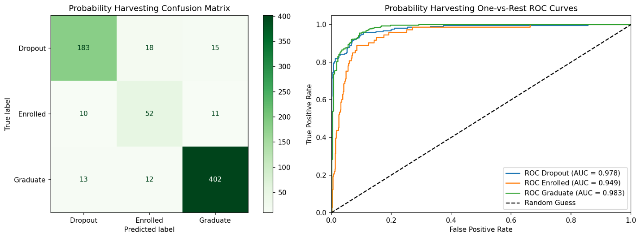
Figure 5. Probability Harvesting Confusion Matrix and OvR ROC Curves
Source : Experimental Results (2026)

The probability harvesting benchmark achieves an accuracy of 88.97%, and F1 score of 0.8262. Notably, the assessment is done considering the prediction uncertainty using the log loss function; here, the benchmark yields a high loss of 0.8979, which contrasts sharply with the extremely low log loss value of 0.2687 obtained using the DCS-LCA approach. Clearly, there is a great disparity between the two since the former uses poorly calibrated probability vectors, in comparison with those used by DCS-LCA which directly inherits the highly accurate estimates of the single best local classifier.

DCS-LCA Sensitivity Analysis : Effect of K on Performance
For the optimization of the DCS-LCA scheme, a sensitivity analysis was performed based on various neighborhood values of $K ∈ \{3, 5, ..., 21\}$ against the macro F1-score of the validation set. To guarantee complete protection against data leakage, the split of 70% to 30% within the first training set of 80% was done to create both the specialists and the Dynamic Selection Dataset (DSEL). The DSEL contains 30% ($≈859$ samples) of the first training set, which makes sure that the local region estimation process is performed in an independent validation space (Cavalcanti et al., 2021; Wang et al., 2023).

Table 9. DCS-LCA K-sensitivity : macro and F1 score per-class
K | F1 Macro | F1 Dropout | F1 Enrolled | F1 Graduate | Note
3 | 0.8483 | 0.9065 | 0.6846 | 0.9538
5 | 0.8565 | 0.9157 | 0.7013 | 0.9525
7 | 0.8638 | 0.9130 | 0.7261 | 0.9524 | Optimal
9 | 0.8595 | 0.9104 | 0.7170 | 0.9512
11 | 0.8595 | 0.9104 | 0.7170 | 0.9512
13 | 0.8595 | 0.9104 | 0.7170 | 0.9512
15 | 0.8595 | 0.9104 | 0.7170 | 0.9512
17 | 0.8595 | 0.9104 | 0.7170 | 0.9512
19 | 0.8595 | 0.9104 | 0.7170 | 0.9512
21 | 0.8595 | 0.9104 | 0.7170 | 0.9512

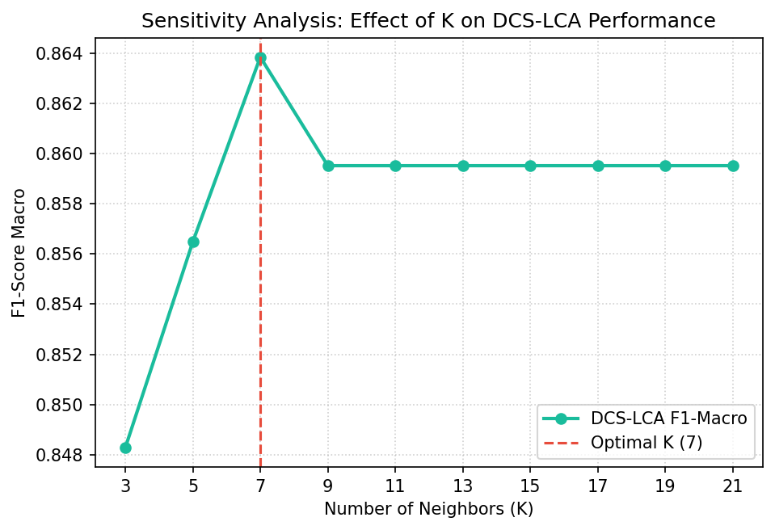
Figure 6. Effect of K on DCS-LCA F1 score
Source : Experimental Results (2026)

Figure 6 shows that the DCS-LCA performance follows an inverted U-shape, maximizing at K = 7 (macro F1 = 0.8638). Low values (K = 3) introduce high uncertainty due to inadequate neighborhood samples, while larger sizes ($K ≥ 9$) over-smooth local differences and diminish dynamic selection benefits. This trend conforms directly to theoretical trade-offs noted by Cordeiro et al. (2023).

DCS-LCA Evaluation (K=7)
The final DCS-LCA model is evaluated on the unseen test set (n=716) with the optimal K=7 neighbourhood. For each test instance the KNN algorithm finds its 7 nearest neighbours in the DSEL pool and each specialist classifier predicts the class of the test point. The local class accuracy (LCA) is calculated as the ratio of correct predictions in the neighbourhood for the predicted class of each classifier. The classifier with the largest LCA is the decision authority.

Table 10. DCS-LCA Classification Report
Metric | Dropout (0) | Enrolled (1) | Graduate (2) | Macro Avg
Precision | 0.95 | 0.68 | 0.94 | 0.86
Recall | 0.88 | 0.78 | 0.96 | 0.87
F1-Score | 0.91 | 0.73 | 0.95 | 0.86
Support | 216 | 73 | 427 | 716
ROC-AUC (OvR) | 0.988 | 0.960 | 0.987 | 0.9785

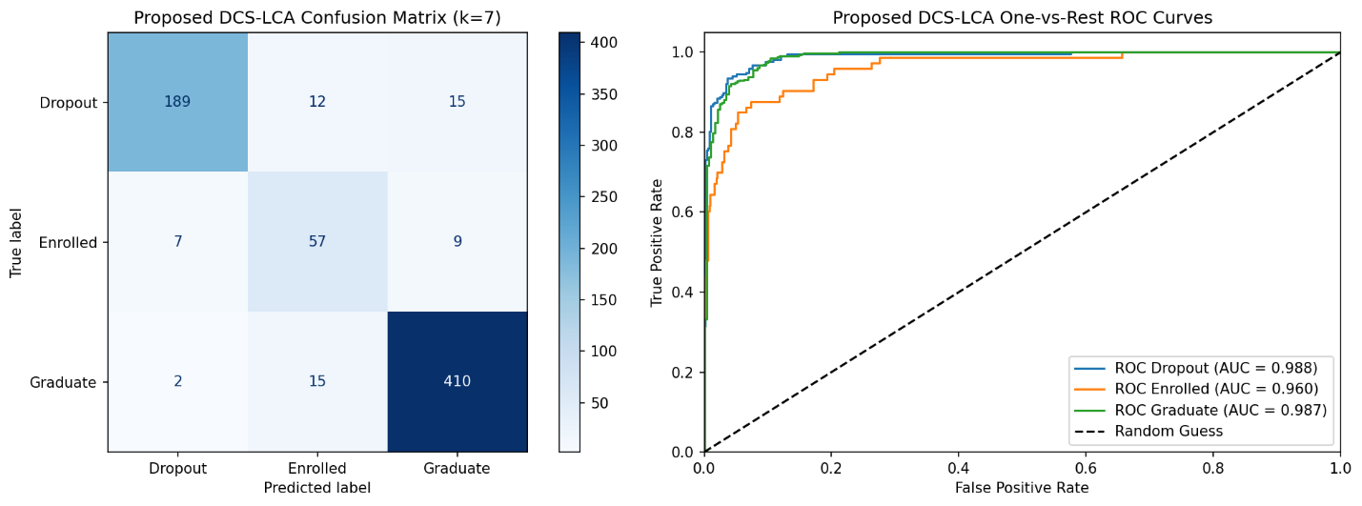
Figure 7. DCS-LCA Confusion Matrix and OvR ROC Curve
Source : Experimental Results (2026)

The DCS-LCA achieves good generalization on the test data with an accuracy of 91.62% and a macro F1-score of 0.8638. The improvement is mainly due to its capability of reducing class ambiguity and false positives. DCS-LCA reduces errors from the Dropout class by lowering the false positive inflow of Enrolled instances from 10 to 7, and Graduate instances from 13 to 2. For the Enrolled class, DCS-LCA decreases the baseline error rate by reducing misclassification of Dropout instances from 18 to 12, while the misclassification of Graduate cases slightly increases from 12 to 15.

Comparative Analysis : Probability Harvesting vs DCS-LCA
To validate the effectiveness of the proposed dynamic ensemble framework, we performed a comprehensive comparative analysis of the traditional Probability Harvesting baseline versus the proposed DCS-LCA architecture. The global and class-wise performance metrics are shown in Table 11, and the confusion matrices and One-vs-Rest (OvR) ROC curves on the unseen test set are compared side by side in Figures 8 and 9.

Table 11. Global performance comparison : Probability Harvesting vs DCS-LCA
Metric | Probability Harvesting | DCS-LCA | Delta | Relative Gain
Accuracy | 0.8897 | 0.9162 | +0.0265 | +2.98%
Logloss | 0.8979 | 0.2687 | -0.6292 | -70.08%
ROC-AUC | 0.9697 | 0.9785 | +0.0088 | +0.91%
F1 Macro | 0.8262 | 0.8638 | +0.0376 | +4.56%
F1 Dropout | 0.8673 | 0.9130 | +0.0457 | +5.27%
F1 Enrolled | 0.6710 | 0.7261 | +0.0551 | +8.21%
F1 Graduate | 0.9404 | 0.9524 | +0.0120 | +1.28%

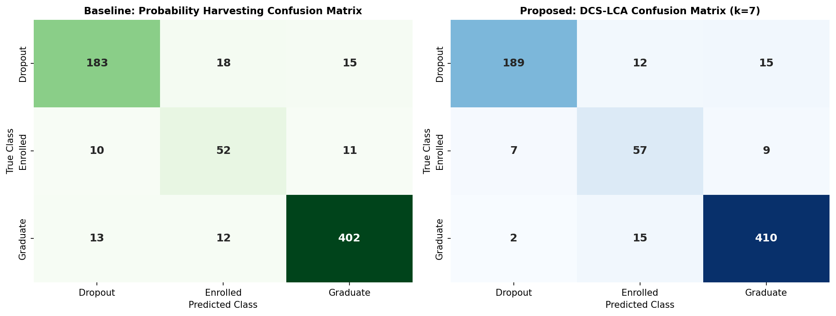
Figure 8. Confusion matrix comparision : Probability Harvesting vs DCS-LCA
Source : Experimental Results (2026)

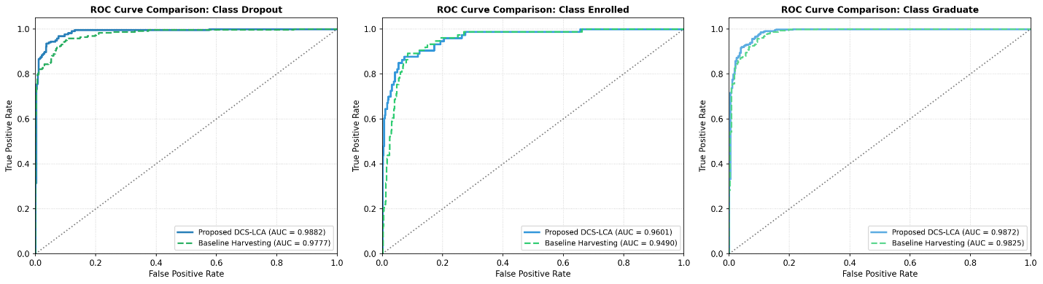
Figure 9. OvR ROC curve comparison : Probability Harvesting vs DCS-LCA
Experimental Results (2026)

As summarized in Table 11, DCS-LCA uniformly outperforms the Probability Harvesting baseline on all performance measures on the unseen test set. Most notably, the most significant improvement is observed in the Log Loss metric, which decreases from 0.8979 to 0.2687 with a remarkable relative gain of -70.08%. The sharp drop is a clear indication of huge improvement in the accuracy of probability estimation since Log Loss penalizes false confidence heavily. The DCS-LCA method addresses the issue of prediction values from out of the domain being incorporated by the base approach since the fixed soft voting technique is non-selective, and it selects only the most locally competent single expert from the K=7 neighborhood pool.
A per-class granular analysis shows that the proposed model can handle the severe class overlap present in transitional student data, more than global metrics. This is especially true for the very unstable Enrolled class, for which the dynamic selection engine obtains a remarkable relative improvement of +8.21%, improving the F1-score from 0.6710 to 0.7261. At the same time, the critical Dropout F1-score improves by +5.27% (to 0.9130), which directly improves the reliability of early institutional interventions. These consistent improvements, along with consistent gains in overall accuracy (+2.98%) and Macro ROC-AUC (+0.91%), indicate that it is indeed beneficial to leverage the local classifiers’ expertise instead of relying on conventional static harvesting methods.

Discussion
Why DCS-LCA Outperforms Static Probability Harvesting
The experimental results confirm the main hypothesis of this work: dynamic classifier selection conditioned to local class accuracy produces systematically better performance than static soft-voting, when both are based on the same pool of specialists. Three mechanisms account for this advantage:
- Competence regionalization: the feature space of student dropout prediction is heterogeneous. Graduate students are grouped closely together, while Enrolled students are spread out near the Dropout and Graduate boundaries. DCS-LCA takes advantage of this structure by choosing the specialist that is most locally accurate for each test point instead of using uniform weights, as indicated by the DES-KNN analysis (Cavalcanti & Enembreck, 2021).
- Log loss superiority: The log loss reduction from 0.8979 to 0.2687, a 70.08% improvement, is especially relevant for educational decision support systems, where probability outputs are leveraged for risk-stratified interventions. Probability harvesting normalizes probability columns from specialists with heterogenous calibration standards, leading to aggregate vectors that are systematically overconfident or underconfident in transition zones. DCS-LCA, which inherits probabilities from a single locally competent model, maintains its calibration properties (Osei et al., 2025).
- Class overlap handling without synthetic augmentation: By removing KNN-borderline noisy instances before training and applying dynamic selection at inference time, the framework avoids the categorical incompatibility of SMOTE-based oversampling (Fernandez-Garcia et al., 2021; Velarde et al., 2024) whilst still improving minority class performance. The Enrolled F1-score improvement of +8.21% from 0.6710 to 0.7261 on the most difficult class validates this approach.

Comparison with Related Work on UCI Dataset #697
Table 12 contextualises DCS-LCA results against prior published work on the same UCI dataset. DCS-LCA achieves the highest reported accuracy (91.62%) and macro F1-score (0.8638) among comparable published methods, while uniquely addressing both categorical feature integrity and class overlap via population-level KNN cleaning without synthetic oversampling.

Table 12. Comparison with related studies on UCI ML Repository #697
Study | Method | Accuracy | Macro F1 | Key Limitation
Villar & de Andrade (2024) | LightGBM + Optuna | Not Reported | 0.8567 (Estimated) | Single global classifier, imbalance not addresed
Lu et al. (2025) | Course-Level Clustering + Tuned LightGBM | 0.8466 (Baseline) | 0.8266 (Cross-cluster Avg) | Requires per-course clustering; no dynamic selection.
Goran et al. (2024) | XGBoost Multi-Class Classification | 0.8005 | 0.7448 | SMOTE on categorical features; global static model.
Osei et al. (2025) | Stacked Ensemble (Static) | Not Reported | Not Reported | Static stacking, calibration not addressed
This study | DCS-LCA + Specialist Pool | 0.9162 | 0.8638 | Dependent on localized neighborhood density (K=7).

CONCLUSION AND FUTURE RESEARCH
Conclusion
This study confirms the performance and calibration efficiency of the proposed DCS-LCA framework (K=7) on the UCI Student Success repository #697. The framework achieves a benchmark global accuracy of 91.62% and a macro F1-score of 0.8638. Most notably, the dynamic routing algorithm demonstrated superior results compared to the Probability Harvesting soft-voting mechanism due to its ability to decrease the value of log-loss by 70.08%. While the baseline deteriorates calibration by blending heterogeneous standards into overconfident/underconfident vectors within transitional zones, DCS-LCA maintains high-calibration performance by adopting probability estimates from the best-fitting specialist within a given neighborhood. Supported by the population-based KNN data cleansing methodology for separating class overlaps and preserving category feature consistency without using artificial oversampling, this framework secures a precise overall classification profile with true positive rates of 87.50% for dropouts, 78.08% for enrolled students, and 96.02% for graduates. These outcomes confirm that replacing global probability blending with local competence estimation establishes a highly robust and calibrated decision space.

Limitations and Future Research
There are some limitations of this paper that define avenues for future exploration. First, the 30% static division of DSELs clearly shrinks the size of the data for training the base specialists in this case, and in the future, cross-validation based pool generation will be used to keep the whole training data. Second, the DCS-LCA engine incurs an $O (N . K)$ inference complexity due to localized neighborhood distance calculations, posing scalability challenges that can be mitigated by integrating spatial indexing structures (e.g., KD-Trees) to accelerate retrieval to $O(log N)$. Last, although there are some improvements, the Enrolled class still demonstrates poor results due to border ambiguity; this problem may be solved through class-specific dynamic pruning or thresholding within the local expert routing layer.

REFERENCES
Akiba, T., Sano, S., Yanase, T., Ohta, T., & Koyama, M. (2019). Optuna: A Next-generation Hyperparameter Optimization Framework (pp. 2623–2631). https://doi.org/10.1145/3292500.3330701
Arshad, I., Li, Y., Zhang, J., Wang, X., & Liu, Y. (2025). Performance of classification algorithms under class imbalance: Simulation and real-world evidence. IEEE Access, 13, 179672–179685. https://doi.org/10.1109/ACCESS.2025.3620264
Altalhan, M., Algarni, A., and Turki-Hadj Alouane, M. (2025). Imbalanced data problem in machine learning: A review. IEEE Access, 13, 13686–13699. https://doi.org/10.1109/ACCESS.2025.3531662
Aziz, K., Ahmed, M., Khan, S., & Rehman, A. (2024). Road traffic crash severity analysis: A Bayesian-optimized dynamic ensemble selection guided by instance hardness and region of competence strategy. IEEE Access, 12, 139540–139559. https://doi.org/10.1109/ACCESS.2024.3465489
Aziz, K., Ahmed, M., Khan, S., & Rehman, A. (2025). An interpretable dynamic ensemble selection multiclass imbalance approach with ensemble imbalance learning for predicting road crash injury severity. Scientific Reports, 15(1), Artikel 24666. https://doi.org/10.1038/s41598-025-08935-x
Cavalcanti, L. P., & Enembreck, F. (2021). Dynamic selection of classifiers in data streams with competency pools. Progress in Artificial Intelligence, 10(3), 311–327. https://doi.org/10.1007/s13748-021-00239-w
Chen, T., & Guestrin, C. (2016). XGBoost: A Scalable Tree Boosting System. arXiv (Cornell University). https://doi.org/10.48550/arxiv.1603.02754
Choi, Y.-R., & Lim, D.-J. (2021). DDES: A distribution-based dynamic ensemble selection framework. IEEE Access, 9, 40743–40754. https://doi.org/10.1109/ACCESS.2021.3063254
Cordeiro, P. R. G., Cavalcanti, G. D. C., & Cruz, R. M. O. (2023). Dynamic ensemble algorithm post-selection using hardness-aware oracle. IEEE Access, 11, 86056–86070. https://doi.org/10.1109/ACCESS.2023.3304912
Fachrie, M., Musdholifah, A., & Pulungan, R. (2025). Effectiveness of data resampling and ensemble learning in multiclass imbalance learning. Artificial Intelligence Review, 58(12), Artikel 412. https://doi.org/10.1007/s10462-025-11357-w
Fernandez-Garcia, J., Preciado, J. C., Rodriguez-Echeverria, R., Sanchez-Figueroa, F., & Conejero, J. M. (2021). A real-life machine learning experience for predicting university dropout at different stages using academic data. IEEE Access, 9, 133076–133090. https://doi.org/10.1109/ACCESS.2021.3115851
Ganie, S. M., Pramanik, P. K. D., & Zhao, Z. (2025). Lifestyle data-based multiclass obesity prediction with interpretable ensemble models incorporating SHAP and LIME analysis. Scientific Reports, 15(1), Artikel 36916. https://doi.org/10.1038/s41598-025-20936-4
Gorani, R., Jovanovic, L., Bacanin, N., Stanković, M. S., Simic, V., Antonijevic, M., & Zivkovic, M. (2024). Identifying and understanding student dropouts using metaheuristic optimized classifiers and explainable AI techniques. IEEE Access, 12, 122377–122400. https://doi.org/10.1109/ACCESS.2024.3446653
Hsu, C.-W., Chang, C.-C., & Lin, C.-J. (2003). A practical guide to support vector classification. National Taiwan University. https://www.csie.ntu.edu.tw/~cjlin/papers/guide/guide.pdf
Jain, A., Kumar, R., Singh, S., & Sharma, P. (2025). A text-based weighted ensemble framework with SMOTE balancing for student dropout prediction in smart education systems. Scientific Reports, 15(1), Artikel 17463. https://doi.org/10.1038/s41598-025-97506-1
Kabumba, R. K., Mutambo, M., Chanda, J., & Phiri, J. (2025). Predictive modeling of academic success using machine learning: A comparative analysis with SMOTE-based class balancing. Procedia Computer Science, 272, 242–250. https://doi.org/10.1016/j.procs.2025.10.202
Liu, S. M., Chen, J.-H., & Z. Liu. (2023). An empirical study of dynamic selection and random under-sampling for the class imbalance problem. Expert Systems with Applications, 221, Artikel 119703. https://doi.org/10.1016/j.eswa.2023.119703
Lu, Y., Yeom, S., Ryu, R., & Kim, S.-H. (2025). Course-level clustering to enhance dropout prediction accuracy. IEEE Access, 13, 204996–205013. https://doi.org/10.1109/ACCESS.2025.3639083
Malik, S., Khan, A., Mohammad, S., & Gupta, R. (2025). Advancing educational data mining for enhanced student performance prediction. Scientific Reports, 15(1), Artikel 8738. https://doi.org/10.1038/s41598-025-92324-x
Mienye, D., & Sun, Y. (2022). A survey of ensemble learning: Concepts, algorithms, applications, and prospects. IEEE Access, 10, 99129–99149. https://doi.org/10.1109/ACCESS.2022.3207287
Osei, S., Masegosa, A. R., & Masegosa, A. D. (2025). Understanding the role of diversity in ensemble-based AutoML methods for classification tasks. IEEE Access, 13, 63566–63586. https://doi.org/10.1109/ACCESS.2025.3554093
Realinho, M. V., Machado, J., Martins, L., & Becker, J. D. (2022). Predicting student dropout and academic success. Data, 7(11), Artikel 146. https://doi.org/10.3390/data7110146
Schölkopf, B., & Smola, A. J. (2001). Learning with Kernels. https://doi.org/10.7551/mitpress/4175.001.0001
Singh, H. P., & Alhulail, H. N. (2022). Predicting student-teachers dropout risk and early identification: A four-step logistic regression approach. IEEE Access, 10, 6470–6482. https://doi.org/10.1109/ACCESS.2022.3141992
Villar, A., & De Andrade, C. R. V. (2024). Supervised machine learning algorithms for predicting student dropout and academic success: A comparative study. Discover Artificial Intelligence, 4(1), Artikel 5. https://doi.org/10.1007/s44163-023-00079-z
Velarde, G., Torrez, M., Flores, R., & Choque, J. (2024). Tree boosting methods for balanced and imbalanced classification and their robustness over time in risk assessment. Intelligent Systems with Applications, 22, Artikel 200354. https://doi.org/10.1016/j.iswa.2024.200354
Wang, X., Li, Y., & Zhang, J. (2024). Weighted ensemble based on differentiated sampling rates for imbalanced classification and application to credit risk assessment. Expert Systems with Applications, 262, Artikel 125595. https://doi.org/10.1016/j.eswa.2024.125595
Wang, Y., Zhang, Y., & Liu, X. (2023). An enhanced dynamic ensemble selection classifier for imbalance classification with application to corporate default prediction. IEEE Transactions on Reliability, 72(4), 1432–1446. https://doi.org/10.1109/TR.2023.3289012
Wu, J., Shen, J., Xu, M., & Shao, M. (2021). A novel combined dynamic ensemble selection model for imbalanced data to detect COVID-19 from complete blood count. Computer Methods and Programs in Biomedicine, 211, Artikel 106444. https://doi.org/10.1016/j.cmpb.2021.106444

ACKNOWLEDGMENT
The authors would like to express their gratitude to Bina Nusantara (BINUS) University, especially the Computer Science Department, for providing the academic resources and institutional support that made this research possible. We are also grateful to our mentors and peers who continuously guided us throughout the development of this study.

Author Biographies
Martinus Alvin Haryanto is an undergraduate student in the Department of Computer Science at Bina Nusantara University, Indonesia, with a specialized background in data science and analytics. His areas of interest in data science include machine learning, specifically the areas of unsupervised learning and ensemble learning. He has practical experience in building end-to-end pipelines in machine learning and optimizing model performance. His applied research addresses two separate fields. He applies unsupervised algorithms for clustering purposes as well as analysis of genetic markers in the bioinformatics domain. Additionally, in finance data science, he focuses on the analysis of the complex correlation between prices of commodities. He is dedicated to advancing scientific discourse through ongoing research initiatives within the rapidly advancing domains of machine learning and intelligent systems.

Joel Chriscendo Rahardjo Liem is an undergraduate student in Computer Science at Binus University (Universitas Bina Nusantara), Indonesia, specializing in the Data Science track. He is currently pursuing his Bachelor of Computer Science degree with a strong academic focus on data-driven methodologies and intelligent systems. His research interests encompass data science, machine learning, and artificial intelligence, with particular enthusiasm for developing analytical models and applying computational techniques to solve real-world problems. As an emerging researcher, Joel is actively building his foundation in statistical learning, data processing, and AI model development. He is committed to contributing to the academic and scientific community through future research endeavors in the rapidly evolving fields of machine learning and intelligent computing.

Stefano Budi is an undergraduate student in the Department of Computer Science at Bina Nusantara University, Indonesia, with a specialized major in Data Science and Analytics. His areas of research interest span Machine Learning, Artificial Intelligence, Deep Learning, Data Mining, and Quantitative Analysis, reflecting a broad and interdisciplinary approach to data-driven problem solving. He has hands-on experience applying machine learning models to real-world problems, with a particular focus on finance-related challenges such as predictive modeling, risk assessment, and data-driven decision making in financial contexts. Through his academic journey, Stefano has developed a strong foundation in statistical learning, computational methods, and analytical frameworks. He is dedicated and committed to advancing both the academic community and the finance industry through rigorous future research and meaningful contributions to the evolving landscape of intelligent data systems.

Kristien Margi Suryaningrum is a Faculty Member in the Computer Science Department at Bina Nusantara University, Indonesia. She holds a Bachelor of Computer Science (S.Kom.) and a Master of Computer Science (M.Cs.) degree. Her main research interests include computational science, intelligent systems, and software engineering. She is passionate about contributing to the development of the computer science field by engaging in innovative research and technology development initiatives. she engages in various research initiatives in a multidisciplinary context and emphasizes practical, data-driven solutions to computational challenges. Through her dedication to academia and students’ mentoring, She actively mentors young scientists in their efforts to create valuable contributions to the scientific community.

Ricky Reynardo Siswanto is a member of the Computer Science department’s faculty at Bina Nusantara University, Indonesia. He holds a Master of Computer Science (M.Kom.) degree. His field of research specialization includes artificial intelligence, machine learning, and computational science. Ricky Siswanto is focused on the advancement of applied computing through his participation in various academic and scientific researches. He mentors and works on research problems involving data-based challenges such as predictive modeling and intelligent systems. Through mentoring his students, he ensures that they are able to work at the forefront of scientific knowledge and participate constructively within the scientific community.

